The Study of History in Jewish Tradition Part I: Chazal's History

1) Taanit 29a
ובשניה, מנלן? דתניא: מגלגלין זכות ליום זכאי וחובה ליום חייב

And the Second [Temple] from where do we know [that it was destroyed on the 9th of Av]? As we learnt in a beraita: we roll [attribute] merit to an innocent [worthy] day and demerit to a guilty day.

2) R. Nosson Nota Hanover, Yeven Metzulah (p. 16)

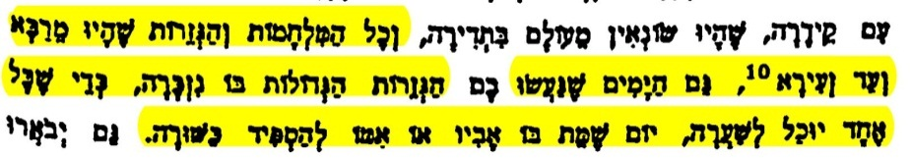

And all the wars and decrees from large to small, also the days on which these decrees were made is recalled, so that each one is able to estimate, the day on which his father or mother died to eulogize them properly.

3) Azariah de-Rossi, Meor Einayim (p. 189)

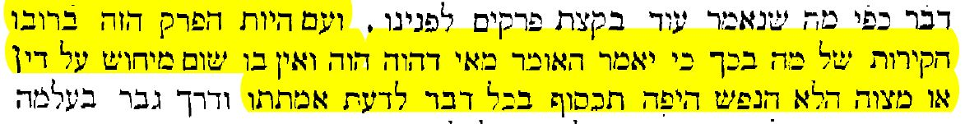

Now the greater part of this chapter has been devoted to inconsequential investigations which one could dismiss by saying “what happened, happened” or on the grounds that it has no bearing on any law or precept. Nevertheless, the refined soul yearns to know the truth of every matter.

4) Seder Olam Rabbah, Chapter 30

ואין אתה מוצא לפרס מלכים, אלא ב' כורש ודריוש, ולמדי ב', דריוש ואחשורוש, אלא הוא כורש, הוא דריוש, הוא ארתחשסתא, לפי שכל המלכות נקראת ארתחשסתא, כל שני מלכי מדי ופרס חמשים ושתים שנה...ר' יוסי אומר מלכות פרס בפני הבית ל"ד שנה, מלכות יון מאה ושמונים, מלכות בית חשמונאי מאה ושלש, מלכות הורודוס מאה ושלש, מכאן ואילך צא וחשוב לחרבן הבית (שנה 420)...

And we do not find Persian kings but two, Cyrus and Darius. And to Media two: Darius and Ahaseurus. Except that [Darius] is also [the kings the Tanakh refers to as] Cyrus, Darius, and Artaxerxes. All the years of the kings of Media and Persia are 52 years. . . . R. Yose said: Persia reigned 34 years before the [Second] Temple, the Greek kingdom lasted 180 years, the Hasmonean kingdom was 103, the Herodian [dynasty] was 103, from there on you can calculate the [number of years from the building of the Second Temple] to the destruction of the Temple [420 years].

5) Rosh Hashanah 3b

תנא הוא כורש הוא דריוש, הוא ארתחשסתא. כורש שמלך כשר היה, ארתחשסתא על שם מלכותו, ומה שמו דריוש שמו.

We learned: Cyrus, Darius, and Artaxerxes are one in the same. He was called Cyrus [Koresh] because he was good [kasher], Artaxerxes was the name of the dynasty [like Pharoah], and what was his name? Darius was his name.

6) Meor Einayim (p. 275)

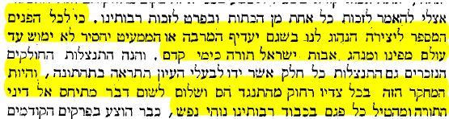

In any event, regardless of whatever increases or subtractions that will be made to the count from Creation, we shall always retain it: the custom of the ancestors of Israel has the status of Torah as in the days of old. . . . Opposition to anything related to the laws of the Torah is far from the object of this investigation, nor will anything be proposed that would mar the honor of our rabbis, may they rest in peace.

7) Meor Einayim (p. 303)

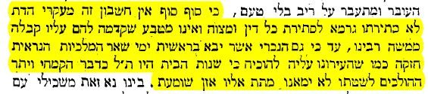

For in the final analysis, this computation is not a tenet of the faith and its reputation is not to the detriment of any law or precept nor does it form an integral part of the ancient tradition transmitted to them by Moses our teacher.

8) Meor Einayim (p. 276)

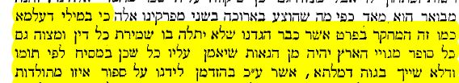

For in secular matters like this investigation about which we already explained that has no bearing on the observance of any law or precept, we deem it appropriate to rely on any writer from the nations of the land, especially when they speak impartially and have no vested interests in the issue at stake.

9) Ezra 4: 5-7

(ה) וְסֹכְרִים עֲלֵיהֶם יוֹעֲצִים לְהָפֵר עֲצָתָם כָּל יְמֵי כּוֹרֶשׁ מֶלֶךְ פָּרַס וְעַד מַלְכוּת דָּרְיָוֶשׁ מֶלֶךְ פָּרָס: (ו) וּבְמַלְכוּת אֲחַשְׁוֵרוֹשׁ בִּתְחִלַּת מַלְכוּתוֹ כָּתְבוּ שִׂטְנָה עַל יֹשְׁבֵי יְהוּדָה וִירוּשָׁלִָם: (ז) וּבִימֵי אַרְתַּחְשַׁשְׂתָּא כָּתַב בִּשְׁלָם מִתְרְדָת טָבְאֵל וּשְׁאָר כנותו כְּנָוֹתָיו עַל ארתחששתא אַרְתַּחְשַׁשְׂתְּ מֶלֶךְ פָּרָס וּכְתָב הַנִּשְׁתְּוָן כָּתוּב אֲרָמִית וּמְתֻרְגָּם אֲרָמִית:

5. And they would hire advisors against them to frustrate their plan, all the days of Cyrus, the king of Persia, and until the kingdom of Darius, the king of Persia.
6. And in the reign of Ahasuerus, in the beginning of his reign, they wrote an accusation against the dwellers of Judea and Jerusalem.
7. And in the days of Artaxerxes, Mithredath Tabeel and the rest of his colleagues wrote with peace, to Artaxerxes, the king of Persia, and the script of the epistle was written in Aramaic and explained in Aramaic.

10) Meor Einayim (p. 316)

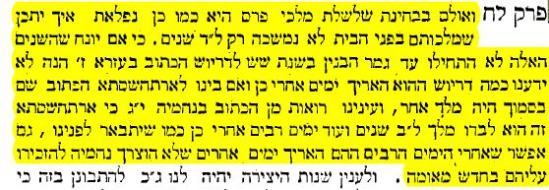

Now when considered from the perspective of the succession of Persian kings, it is also surprising that the Persian rule could have lasted only 34 years during Temple times. For one might assume that this period of 34 years only began after the building of the Temple had been completed in the sixth year of Darius’s reign as is written in chapter 6 of Ezra; but then there is no information as to how long Darius lived subsequently. Nor do we know whether there was another king between his reign and that of Artaxerxes who is the next king mentioned. From our reading of chapter 13 of Nehemiah, we observe that Artaxerxes alone reigned 32 years, as well as for a significant period of time subsequently as shall be clarified. It is also possible that he lived even longer after that period; but Nehemiah had no need to mention it because there was nothing new to record.

11) Meor Einayim (p. 326)

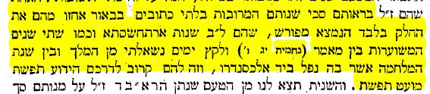

When they noticed that the greater number of years [of the Persian kings] was not clearly given in Scripture, they took into account only that section of years which was given explicitly, namely the 32 years of Artaxerxes and about 2 years which are estimated to have elapsed between the time in which it was stated, and when some time had gone by I asked permission from the king (Neh. 13:6) and the year of the war during which he was captured by Alexander. This was in line with their well known method of adhering to the smallest possible figure.

12) Daniel 9:24-27

כד) שָׁבֻעִים שִׁבְעִים נֶחְתַּךְ עַל עַמְּךָ וְעַל עִיר קָדְשֶׁךָ לְכַלֵּא הַפֶּשַׁע ולחתם וּלְהָתֵם חטאות חַטָּאת וּלְכַפֵּר עָוֹן וּלְהָבִיא צֶדֶק עֹלָמִים וְלַחְתֹּם חָזוֹן וְנָבִיא וְלִמְשֹׁחַ קֹדֶשׁ קָדָשִׁים:
כה) וְתֵדַע וְתַשְׂכֵּל מִן מֹצָא דָבָר לְהָשִׁיב וְלִבְנוֹת יְרוּשָׁלִַם עַד מָשִׁיחַ נָגִיד שָׁבֻעִים שִׁבְעָה וְשָׁבֻעִים שִׁשִּׁים וּשְׁנַיִם תָּשׁוּב וְנִבְנְתָה רְחוֹב וְחָרוּץ וּבְצוֹק הָעִתִּים::
כו) וְאַחֲרֵי הַשָּׁבֻעִים שִׁשִּׁים וּשְׁנַיִם יִכָּרֵת מָשִׁיחַ וְאֵין לוֹ וְהָעִיר וְהַקֹּדֶשׁ יַשְׁחִית עַם נָגִיד הַבָּא וְקִצּוֹ בַשֶּׁטֶף וְעַד קֵץ מִלְחָמָה נֶחֱרֶצֶת שֹׁמֵמוֹת:
כז) וְהִגְבִּיר בְּרִית לָרַבִּים שָׁבוּעַ אֶחָד וַחֲצִי הַשָּׁבוּעַ יַשְׁבִּית זֶבַח וּמִנְחָה וְעַל כְּנַף שִׁקּוּצִים מְשֹׁמֵם וְעַד כָּלָה וְנֶחֱרָצָה תִּתַּךְ עַל שֹׁמֵם:

24. Seventy weeks have been decreed upon your people and upon the city of your Sanctuary to terminate the transgression and to end sin, and to expiate iniquity, and to bring eternal righteousness, and to seal up vision and prophet, and to anoint the Holy of Holies.
25. And you shall know and understand that from the emergence of the word to restore and to rebuild Jerusalem until the anointed king [shall be] seven weeks, and [in] sixty-two weeks it will return and be built street and moat, but in troubled times.
26. And after the sixty-two weeks, the anointed one will be cut off, and he will be no more, and the people of the coming monarch will destroy the city and the Sanctuary, and his end will come about by inundation, and until the end of the war, it will be cut off into desolation.
27. And he will strengthen a covenant for the princes for one week, and half the week he will abolish sacrifice and meal- offering, and on high, among abominations, will be the dumb one, and until destruction and extermination befall the dumb one.

13) Ramban, Vikuah ha-Ramban

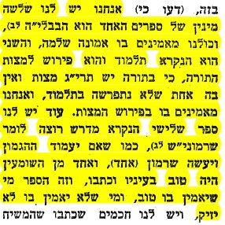

We have three types of books. The first is the Bible, and we all believe in it with complete faith, the second is the Talmud and it is an explanation of the mitzvoth of the Torah, for in the Torah there are 613 mitzvoth and there is not one that is not explained in the Talmud. We also have a third book, called midrash, or sermons, just like if the governor got up and said a sermon, and one of the pieces was good in his eyes and he wrote it down. And as for this book—one who believes it—fine, and one who does not believe it, there is no harm done.

14) Rambam, Moreh Nevukhim 2:14

You must, however, not expect that everything our Sages say respecting astronomical matters should agree with observation, for mathematics were not fully developed in those days; and their statements were not based on the authority of the Prophets, but on the knowledge which they either themselves possessed or derived from contemporary men of science.

15) Ibn Ezra, Commentary on the Torah (Peirush ha-Katzar), Shemot 2:10

גם שם (בספר עזרא) פירשתי "כל ימי כורש ודריוש וארתחששתא" (עזרא ו:יד)--שהם שלשה.

16) Ba’al ha-Maor, beginning of Rosh Hashanah

גם שם (בספר עזרא) פירשתי "כל ימי כורש ודריוש וארתחששתא" (עזרא ו:יד)--שהם שלשה.

17) Daniel 11:1-2

א) וַאֲנִי בִּשְׁנַת אַחַת לְדָרְיָוֶשׁ הַמָּדִי עָמְדִי לְמַחֲזִיק וּלְמָעוֹז לוֹ
ב) וְעַתָּה אֱמֶת אַגִּיד לָךְ הִנֵּה עוֹד שְׁלֹשָׁה מְלָכִים עֹמְדִים לְפָרַס וְהָרְבִיעִי יַעֲשִׁיר עֹשֶׁר גָּדוֹל מִכֹּל וּכְחֶזְקָתוֹ בְעָשְׁרוֹ יָעִיר הַכֹּל אֵת מַלְכוּת יָוָן

1. As for me, in the first year of Darius the Mede, I stood as a supporter and a stronghold for him.
2. And now, I shall tell you the truth. Behold three more kings will arise in Persia, and the fourth one will become wealthy with great wealth, and when be becomes strong with his wealth, he will arouse all against the kingdom of Greece.

18) Maharal (R. Yehuda Loew) of Prague, Be’er ha-Golah (p. 139-141)

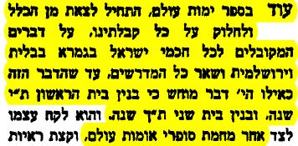

Also in his book on the days of the world, he begins to leave the community and disagree with our received tradition, regarding matters that were accepted by all the Jewish Sages in the Bavli, the Yerushalmi, and all the other Midrashim, until it was something obvious that the First Temple was 410 years and the Second Temple was 420 years. But he takes himself to the other side because of non-Jewish writers…

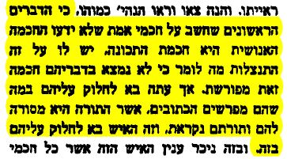

The Rishonim who said about the true Sages that they did not know worldly wisdom such as science, for that they have an excuse because we do not find such wisdom [science] explicit in their words. But now [de Rossi] comes to disagree with them in the way they interpret [Torah] verses—the Torah was given to them and it is called their Torah! And this person comes to disagree with them on this matter?

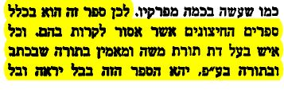
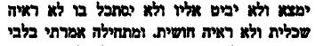

Therefore, let this book be among those outside the pale that are forbidden to read. And for every man of the religion of Moses’ Torah who believes in the written and oral Torah, this book shall not be seen and not be found; do not look upon it or in it, not for intellectual purposes or out of curiosity.

