Choosing Your Chumash, Part II: The Hertz

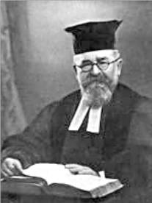
Rabbi Hertz (1872-1946)

1) From the Preface to the First Edition (p. vii)

“This work, which gives the text in Hebrew and English, accompanied by a brief exposition of both the Pentateuch and the Haftorahs for use in Synagogue, School, and Home, supplies a long-felt want among English-speaking Jews. The glosses on the Pentateuch (without the Haftorahs) by David Levi and Isaac Delgado were published 140 years ago, and are, besides, unobtainable today.”

“In the preparation of the Commentary I have had the valuable assistance of Dr. J. Abelson , Dr. A. Cohen, the late Rev. G. Friedlander, and the Rev. S. Frampton. In placing their respective manuscripts at my disposal, they allowed me the widest editorial discretion. I have condensed or enlarged, re-cast or re-written at will, myself supplying the Additional Notes as well as nearly all the introductory and concluding comments to the various sections.”

“Jewish and non-Jewish commentators--ancient, medieval, and modern--have been freely drawn upon. ‘Accept the true from whatever source it come,’ is sound Rabbinic doctrine--even if be from the pages of a devout Christian expositor or of an iconoclastic Bible scholar, Jewish or non-Jewish. This does not affect the Jewish Traditional character of the work. My conviction that the criticism of the Pentateuch associated with the name of Wellhausen is a perversion of history and a desecration of religion, is unshaken; likewise, my refusal to eliminate the Divine either from history or from human life.”

2) Preface to the One-Volume Edition (p. vii)

“The Translation in this new edition is the Version of the Holy Scriptures issued by the Jewish Publication Society of America in 1917.”

“A further word must be said as to the nature of the Commentary. Its aim is two-fold; the exposition, firstly, of the ‘plain sense’ of the Sacred Text; and, secondly, of its religious message as affecting everyday problems of human existence, and guiding the life of Israel and Humanity.”

3) Julius Wellhausen, Prolegomena to the History of Israel

“In my student days I was attracted by the stories of Saul and David, Ahab and Elijah; the discourse of Amos and Isaiah laid strong hold on me, and I read myself well into the prophetic and historical books of the Old Testament ... At last I took courage and made my way through Exodus, Leviticus, Numbers ... my enjoyment of the latter was marred by the Law; it ... intruded itself uneasily, like a ghost that makes a noise indeed, but is not visible ... At last, ... I learned ... that ... Graf placed the law later than the Prophets, and almost without knowing his reasons for the hypothesis, I was prepared to accept it; I readily acknowledged to myself the possibility of understanding Hebrew antiquity without the book of the Torah.”

4) Solomon Schechter, “Higher Criticism—Higher Anti-Semitism”

“I remember when I used to come home from the Cheder, bleeding and crying from the wounds inflicted upon me by the Christian boys, my father used to say, ‘My child, we are in Galuth (exile), and we must submit to God’s will.’ And he made me understand that this is only a passing stage in history, as we Jews belong to eternity, when God will comfort His people. Thus the pain was only physical, but my real suffering began later in life, when I emigrated from Roumania to so-called civilized countries and found there what I might call the Higher anti-Semitism, which burns the soul though it leaves the body unhurt. . . . [T]his intellectual persecution can only be fought by intellectual weapons and unless we make an effort to recover our Bible and to think out our theology for ourselves, we are irrevocably lost from both worlds. A mere protest in the pulpit or a vigorous editorial in a paper, or an amateur essay in a monthly, or even a special monograph will not help us. We have to create a really living, great literature, and do the same for the subjects of theology and the Bible that Europe has done for Jewish history and philology.”

5) Are There Two Conflicting Accounts of Creation and the Deluge in the Bible? (p. 199)

“The procedure of the critics in connection with the Creation and Deluge chapters is typical of their method throughout. It justifies the protest of the late Lord Chancellor of England, the Earl of Halsbury--an excellent judge of evidence--who in 1915 found himself impelled to declare:--‘For my own part I consider the assignment of different fragments of Genesis to a number of wholly imaginary authors great rubbish. I do not understand the attitude of those men who base a whole theory of this kind on hypotheses for which there is no evidence whatsoever.’”

6) Is the Code of Hammurabi the Source of the Mosaic Civil Law? (p. 406)

“Once again we have seen that the words of the Psalmist, ‘Truth shall spring from the earth,’ have become literally fulfilled; and the very stones of the Euphrates and Tigris valleys have given their decisive testimony in vindication of the Torah.”

7) Divorce (p. 934)

“The evidence given before the Royal Commission of 1909 confirmed the fact that the Jewish outlook, which recognizes the dissolution of a marriage when the happiness of the home is impossible, was in general harmony with progressive thought, while the Christian outlook was in direct conflict with it.”

8) Commentary to Shemot 3:22 (p. 217)

“The words ‘ve-nitzaltem et mitzrayim’ can only be translated, ‘and ye shall save the Egyptians,’ i.e., clear the name, and vindicate the humanity, of the Egyptians. Bitter memories and associations would have clung to the word ‘Egyptians’ in the mind of the Israelites, as the hereditary enslavers and oppressors of Israel. A friendly parting, and generous gifts, however, would banish that feeling. The Israelites would come to see that the oppressors were Pharaoh and his courtiers, not the Egyptian people. They would be enabled thereby to carry out the command to be given to them forty years later, ‘Thou shalt not abhor an Egyptian.’ (Devarim 23:8)”

9) Hoshea, 1:2

תְּחִלַּת דִּבֶּר ה, בְּהוֹשֵׁעַ: וַיֹּאמֶר ה אֶל-הוֹשֵׁעַ, לֵךְ קַח-לְךָ אֵשֶׁת זְנוּנִים וְיַלְדֵי זְנוּנִים--כִּי-זָנֹה תִזְנֶה הָאָרֶץ, מֵאַחֲרֵי ה

At the beginning of the Lord's speaking to Hosea, the Lord said to Hosea: Go, take yourself a wife of harlotry and children of harlotry, for the land goes astray from following the Lord.

10) Jewish Attitudes Towards Evolution (p. 194)

“Man, modern scientists declare, is cousin to the anthropoid ape. But it is not so much the descent, as the ascent of man, which is decisive. Furthermore, it is not the resemblance, but the differences between man and ape, that are of infinite importance. It is the differences between them that constitute the humanity of man, the God-likeness of man.”

11) The Ten Plagues (p. 400)

“The first nine plagues, though often spoken of as wonders, are not fantastic miracles without any basis in natural phenomena. As everywhere else in Scripture, the supernatural is here interwoven with the natural; and the Plagues are but miraculously intensified forms of the diseases and other natural occurrences to which Egypt is more or less liable.”
12) Balaam and the Ass (p. 671)

“For over a thousand years, however, the literal has largely given place to other interpretations of the incident.”

“Those who do not deem any of the above interpretations acceptable, should feel too deeply the essential veracity of the story to be troubled overmuch with minute questions about its details. In whatever way we conceive of the narrative, its representation of the strivings of conscience is of permanent human and spiritual value.”

13) R. Nosson Scherman’s view (old JTA article no longer online)

“ ‘The Hertz was a masterpiece in its time, a piece of literature. What he did was heroic,’ said ArtScroll's Rabbi Scherman. ‘He was trying to convince people that the Chumash was worthwhile. He would quote Shakespeare, church fathers and other Christian sources. Nowadays, people are offended by that. Now you have people with a yeshiva education. They want to know what the Chumash means to Jews, what the traditional sources have to say.’ ”

14) The Jewish Observer (June 2006) (discussing evolution)

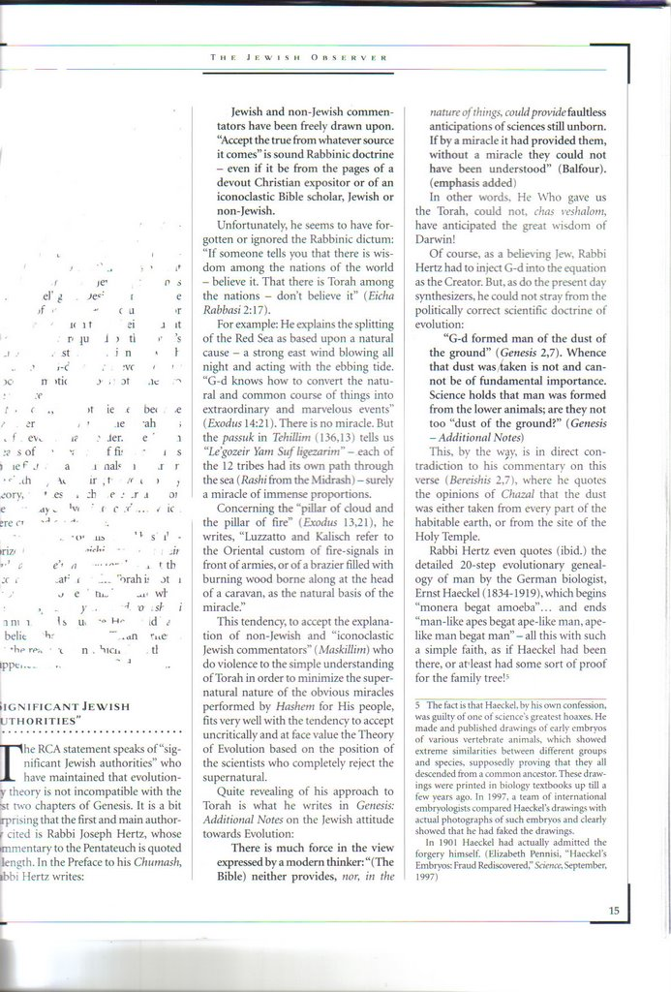

15) Gil Student, “In Defense of Rabbi Hertz”

A recent article objected to certain aspects of the commentary to the Torah edited by R. Joseph H. Hertz. Below are his objections and some responses. But first, let me relate this story:

When I was in yeshiva, a friend of mine who lived in a shrinking Jewish neighborhood brought the following question to R. Ahron Soloveichik: His synagogue was dwindling and had just hired a new rabbi. This rabbi’s first act upon assuming his position was to insist that all the Hertz chumashim be replaced with Artscroll chumashim. The congregants were upset over this and my friend asked R. Ahron what they should do. R. Ahron told him, “There is nothing wrong with the Hertz chumash.” However, since this rabbi was the synagogue’s last hope, they should let him do this. They did, and despite the new rabbi, the synagogue closed down within a few years.

And now to the objections:

1. R. Hertz writes: “Jewish and non-Jewish commentators have been freely drawn upon. ‘Accept the true from whatever source it comes’ is sound Rabbinic doctrine…” The author objects: “Unfortunately, he seems to have forgotten or ignored the Rabbinic dictum: ‘If someone tells you that there is wisdom among the nations of the world — believe it. That there is Torah among the nations — don’t believe it’ (Eicha Rabbasi 2:17).”

This was not an innovation of R. Hertz. As noted earlier (link), Abarbanel quotes Christian commentators regularly. As to the midrash, we apparently have a problem. The simple fact, as easily verifiable by finding a good Christian commentary and looking at it, is that gentiles can and do have insight into the Torah. While they may have many comments to which we object, they can still have profound insight (e.g. Brevard Childs’ classic commentary on Exodus). Either this midrash contradicts a clear and verifiable reality or we are misunderstanding it. I believe the latter to be the case. “Torah” in the midrash can easily mean a way of life, as R. Hershel Schachter has explained it (link). Alternately, it can mean a ruling on halakhic practice; i.e. do not look to gentiles for halakhic rulings.

2. R. Hertz explains Ex. 14:21 (“And the Lord caused the sea to go back by a strong east wind all the night, and made the sea dry land, and the waters were divided”) as follows (quoting Kalisch): “As in all the wonders of Egypt, this also, the greatest of all, is based upon a natural cause; and in this the boundless power of God, who, by an insignificant change, knows how to convert the natural and common course of things into extraordinary and marvellous events, is sublimely manifest.” About this, the author writes: “There is no miracle.”

Reading the excerpt above, that is clearly an incorrect inference. The author quotes the midrash that the sea was split so that there were 12 paths, 1 for each tribe. However, the author seems not to differentiate between peshat and midrash. On a peshat level, there are no 12 paths, and that is the level on which R. Hertz’s commentary is operating. Perhaps more importantly, the objection to the attempt to “naturalize” miracles such as the ten plagues is not necessarily anything wrong. As discussed earlier, the recently published book by R. Joseph B. Soloveitchik, The Emergence of Ethical Man, does just that (I, II)!

3. The author quotes R. Hertz’s commentary to Ex. 13:21 about the pillars of cloud and fire that represented God’s presence as being similar to ancient practices of having fire signals in front of armies, i.e. being a “natural basis of the miracle.” While there is nothing inherently wrong with such an approach, as above, it is worth quoting the next sentence of R. Hertz’s commentary that the author cut off: “In that case, we should have in this narrative of the guiding Cloud and Pillar another instance of the interweaving of the supernatural and the natural in Scripture.” Note the tone of a mere suggestion, rather than an authoritative interpretation and, perhaps more importantly, the explicit acceptance of supernatural. In other words, R. Hertz was saying, “Even if they are right and this was not a supernatural miracle, it does not detract from the wonder.” That, I believe, is of a very different nature than the impression the author gave of R. Hertz trying to remove supernatural events from the Torah.

4. R. Hertz wrote the following in his additional notes to Genesis (p. 195): “There is much force in the view expressed by a modern thinker: ‘(The Bible) neither provides, nor, in the nature of things, could provide, faultless anticipation of sciences still unborn. If by a miracle it had provided them, without a miracle they could not have been understood’ (Balfour).” The author interpreted this to mean: “In other words, He Who gave us the Torah, could not, chas veshalom, have anticipated the great wisdom of Darwin!”

I believe this to be a misinterpretation. In my reading, R. Hertz’s meaning was simply that God, of course, knew how He created the world but could not relay that information clearly in the Torah because the recipients of the Torah were not ready to understand that complex biological mechanism. As R. Slifkin explores in his new book, there are parallels to this approach in the rishonim. It is certainly unthinkable that R. Hertz would claim that God did not know how the world was created. That would contradict everything that R. Hertz taught throughout his life, as evident in his many published writings.

5. The author notes a contradiction between the Additional Notes and the commentary itself. In the Additional Notes, R. Hertz suggests that man being created from the “dust of the ground” (Gen. 2:7) could refer to lower animals while in the commentary to that verse he quotes midrashic interpretations. However, that passage in the commentary is clearly written in a homiletic fashion and not on a peshat level.

6. The author objects to R. Hertz quoting Haeckel’s “monera begat amoeba… man-like ape begat ape-like man, ape-like man begat man” (p. 195). The author writes: “[A]ll this with simple faith, as if Haeckel had been there, or at least had some sort of proof for the family tree!”

But that is all beside the point. R. Hertz was not accepting that as authoritative. He was quoting it as an example of how evolution could not have been recorded in the Torah. The order, the details, the exact language are all beside the point. His point still stands, if one take the time to think about it.

