Rabbi or Rogue? Michael Rodkinson and the First English Translation of the Talmud

Michael Louis Rodkinson (1845-1904)

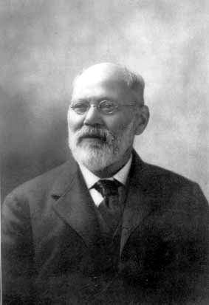
1) Mikhael Ha-Levi Frumkin (Michael Rodkinson), Sippurei Tzaddikim (intro)

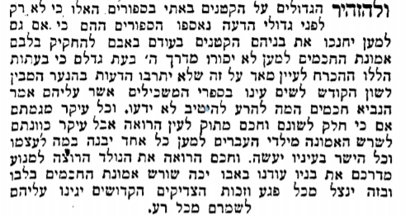

2) Kaufmann Kohler (1843-1926), American Hebrew (1896)

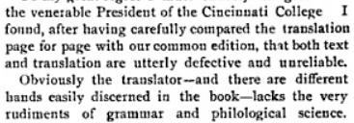

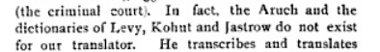

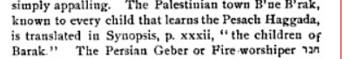

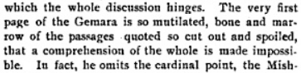

3) Michael Rodkinson, Introduction to Rosh Hashana, “A Few Words to the English Reader”

“If it were translated from the original text one would not see the forest for the trees. . . . As it stands in the original it is, therefore, a tangled mass defying reproductions in a modern tongue. It has consequently occurred to us that in order to enable the Talmud to open its mouth, the text must be carefully edited. A modern book, constructed on a supposed scientific plan, we cannot make of it, for that would not be the Talmud; but a readable, intelligible work it can be made. We have, therefore, . . . re-edited it by omitting all such irrelevant matter as interrupted the clear and orderly arrangement of the various arguments. In this way disappears those unnecessary debates within debates, which only serve to confuse and never to enlighten on the question debated. . . .

4) Zevachim 113b

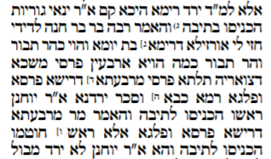

“Said R. Jannai: They took the young [of the re'em] into the Ark. But surely Rabbah b. Bar Hanah said: I saw a sea re'em, one day old, which was as big as Mount Tabor. And how big is Mount Tabor? Forty parasangs. Its neck, stretched out, was three parasangs; the place where its head rested was a parasang and a half. It cast a ball of excrements and blocked the Jordan! — Said R. Johanan: They took its head [only] into the Ark. But a master said: The place where its head rested was three parasangs? — Rather, they took the tip of its nose into the Ark.”

5) Michael Rodkinson, Babylonian Talmud Book 10, Vol. II: Historical and Literary Introduction to the New Edition of the Talmud, Part III

“[Regarding the] r'em (wild-ox), which, according to Rabba b. b. Hannah, the size of its offspring of one day was equal to forty miles, hence it could not in any way be entered in the ark, the answer comes that its snout only was in the ark, and the rest of the body was swimming in the water.
Now we would ask any reader if it is possible that such a thing should be said by any sage of the Talmud, and especially by Resh Lakish, who was one of the greatest Amoraim of Palestine. As this Hagada was discussed in connection with a Halakha it must not by any means be taken as allegorical. It is therefore more than certain that one who desired to make the Talmud ridiculous put in the mouths of Jochanan and Resh Lakish the discussion about the r'em with such a ridiculous answer. Hence in our translation it must be omitted.”

“We do not believe that any one with common sense, and without partiality, can be found who would deny that such things were inserted by the Talmud haters only for the purpose of ridiculing the Talmud. It is self-evident then that in our edition such and numerous similar legends do not find place.”

6) Rabbi Bernard Felsenthal (1822-1906), American Israelite (1895)

“How, in heavens name, did now ‘the enemies of the Talmud’ manage to double and treble the bulk of the Talmud by inserting clandestinely and unbeknown to the rabbis and students such enormous additions?”

7) Makkot 3a

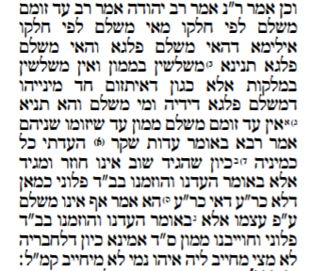

Rodkinson:

“R. Jehuda in the name of Rabh said: A collusive witness pays his share. What does this mean? Shall we assume that in the case where two witnesses were found collusive each of them pays half? This is already stated further on in a Mishna. Or does it mean that if one of them was found collusive, he has to pay half? This is not so, as there is a Boraitha which states that there is no payment imposed unless both are found collusive. Said Rabha: He speaks of the case when one came before the court testifying: I, together with so and so, have testified before such and such a court, and we, having been found collusive, the court has decided that we have to pay such and such an amount. And lest one say that, as his testimony does not make liable his colleague, he himself should not be responsible either, he comes to teach us that this is not so.”

Soncino:

“Said Rab Judah: Rab said that a zomem-witness pays his quota. What is meant by ‘pays his quota’? If it means that this one pays half and that one half, we learn this already expressly: Monetary impositions are divided proportionately, but [the number of] lashes is not divided proportionately!¹ This dictum is applicable where only one of the witnesses was found a zomem, in which case he would be made to pay his half [of the fine]. But does he in such a case pay at all? Is it not taught: ‘No zomem-witness pays money [damages] until the two of them have been found zomemim’? — Said Raba: It has a possible application where one of the zomemim admits, ‘I gave false evidence’. But would we accept such statement coming from him?² What about [the rule]: A witness, once he has made his depositions [before the Court], cannot retract and testify again? — Hence this dictum can only be applied where one says: ‘We gave evidence and were found zomemim by such and such a Court’.³ Now, with whose view will this explanation accord? — Not with R. Akiba's; for how could this accord with what he said: ‘They also do not pay on their own admission’! Hence Rab's dictum is applicable only when one of the witnesses says, ‘We gave evidence, were found zomemim by such and such a Court and were condemned to pay a sum of money’.⁴ Now [in such a case] you might presumably expect me to argue that since this fellow cannot [by his sole statement] commit his confederate, he could not commit himself either; therefore Rab teaches us that in this instance a zomem pays his quota.”

