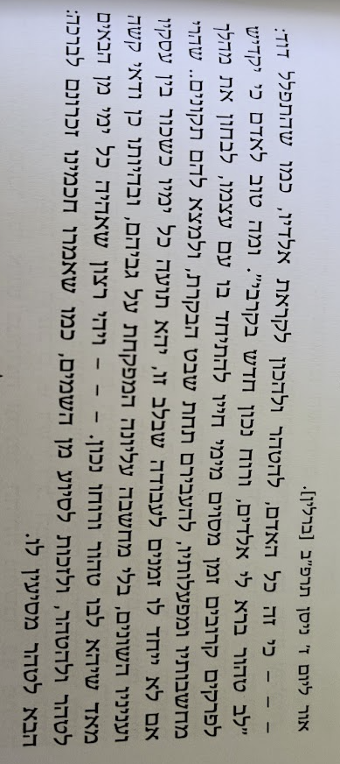
From Slabodka to Berlin: The Short Life of R. Avraham Eliyahu Kaplan

1) Mussar Journal of R. AE Kaplan (1922)
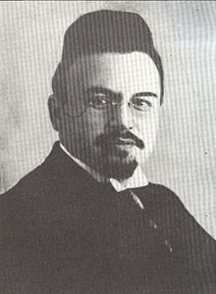

2) Be-Ikvot Ha-Yirah (translation by Hillel Goldberg)

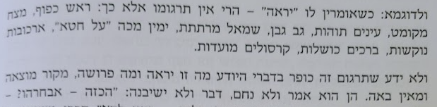

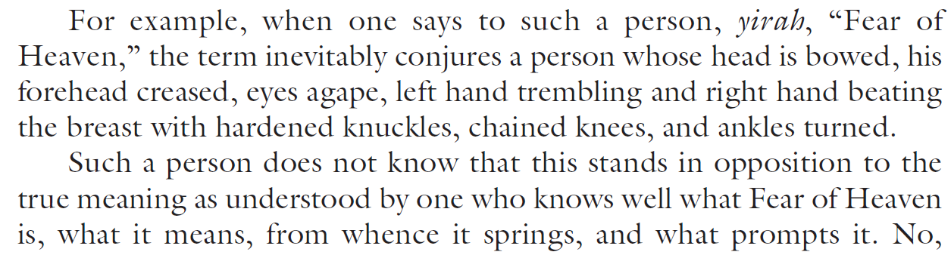

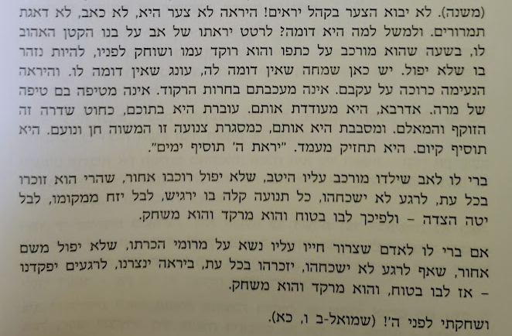
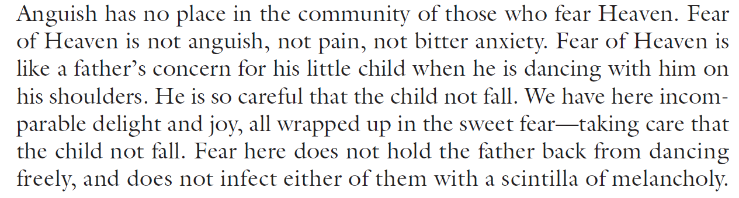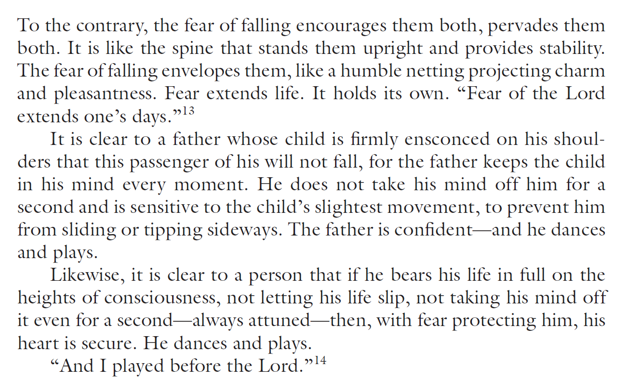

3) R. Azriel Hildesheimer (1820-1899), Inaugural Address of the Berlin Seminary (1873)

“Since the last half-century there has been both an entirely new outpouring of Jewish Wissenschaft, as well as the need to explore other areas cultivated from time immemorial, such as biblical exegesis, from new points of view and with the use of unfathomed new sources. We will incorporate these disciplines into our curriculum and embrace them with love and full scientific seriousness, and thus serve truth and only the truth. Should we be more apologetic due to the nature of our point of view, we will never dishonor our holy cause by setting forth the phrase instead of the thought, the subjective opinion instead of the established proof.”

4) R. David Tzvi Hoffman (1843-1921), Lecture Delivered at the Berlin Seminary (1919)

“Through serious scientific research carried out le-shem shamayim, Torah study can only be promoted and enriched. All concepts will be grasped with scientific clarity, much which is unclear will be illuminated by research, and numerous mistakes will be eradicated.”

5) R. AE Kaplan, Chochmat ha-Umot ve-Chochmat Yisrael, Address at the Beginning of the Term at the Berlin Seminary (1922)

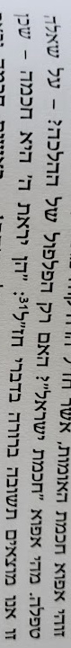

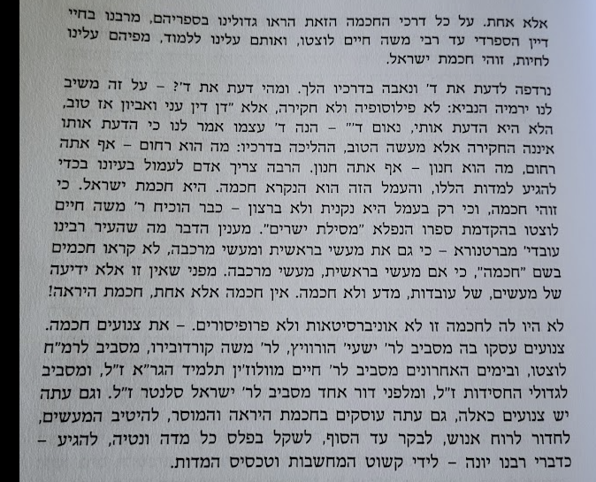

6) Review of Asher Gulak’s Yesodei ha-Mishpat ha-Ivri

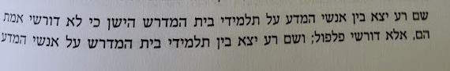
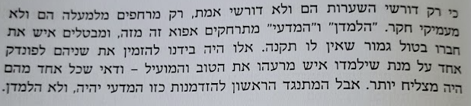

7) Introduction to Divrei Talmud

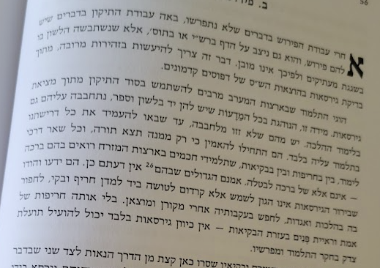

8) Essay on Herzl (1919)

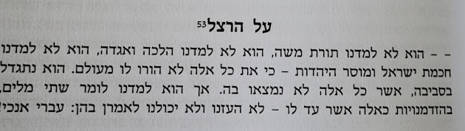

9) Shakah Chamah (1907)

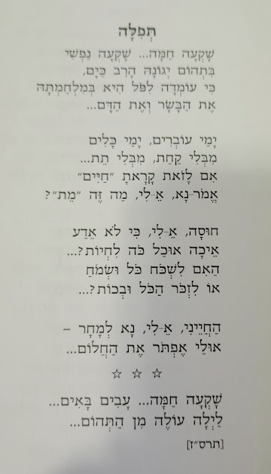

10) Shlomo Yehuda Rechnitz, Additions to Shakah Chamah (2015) (sample)



